|  |  |  |
| --- | --- | --- |
|  |  | **School Newsletter 15th May 2024** |
| **Ltyentye Apurte Catholic School**  Church Street, Santa Teresa, PMB 221, Via Alice Springs, NT, 0872.  Telephone: (08) 8956 0937 email: robert.dreise@nt.catholic.edu.au |

Dear Families,

**Welcome**

A warm welcome to our two new teachers Lauren and James. Lauren is teaching the Year 1/2 class and James is teaching the Year 4/5 class.

Ltyentye Apurte

Catholic School

Welcomes

our two new

Teachers

Lauren & James

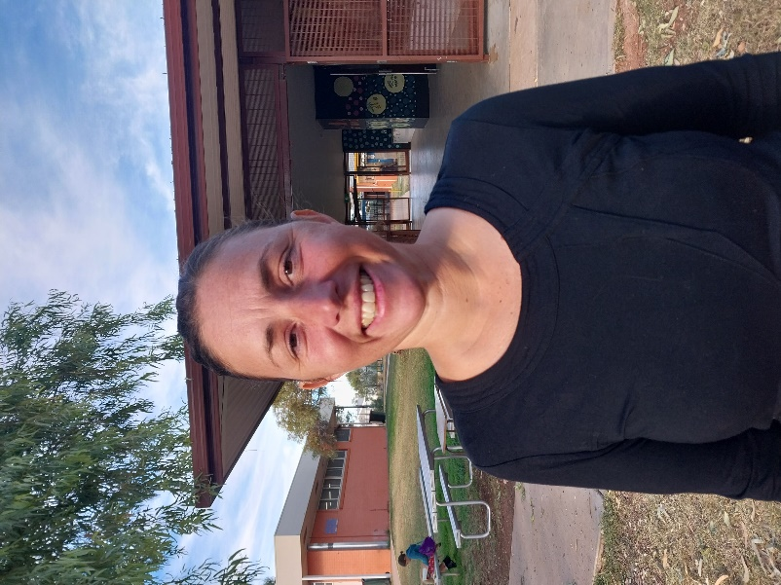

Dear God, as our new teachers prepare for a new life at Santa Teresa, grant them an abundance of Your love and wisdom. Prepare their hearts to welcome and love our loved ones, and may we make sure to show them love and respect in return. We are overwhelmed with gratitude for the gift of learning that they will share with our children. Amen



**Other News**

|  |  |
| --- | --- |
| Life Ed Australia | Our students had a special visitor last week, Healthy Harold and the Life Education Team. The team taught our young people health, safety and wellbeing skills to make better decisions throughout their lives. Harold the Giraffe helped to make the learning fun and engaging. (See pictures below) |
| Quirky and Fun Facts about Mother's Day | A very special “Happy Mothers’ Day” Message to all mums at Santa Teresa. It was wonderful to see so many visitors to our school for the morning tea and special assembly. Thank you to Renee for organising our visitors, Kathy for organising the presents for our new mums and Tony for preparing morning tea. |
| Javelin throwing competition. Cartoon character. Vector illustration Stock  Vector | Adobe Stock | **Sports Day**  Please join us at our 2024 Sports Day to be held on Thursday June 13th. Come along and cheer on the Kangaroos, Emus, Goannas and Perentie as they compete in running, high jump, long jump, shot put, relays, and discus. |
|  | **A reminder that our school is closed before 7:45am. Breakfast will be served at 8:00am**. |
| Hector Storybook | Hector the Road Safety Cat visited our school to deliver an important message about road safety. Hector taught the students about passenger safety, pedestrian safety, safety on wheels and road rules. It was a purrfect program. Remind children in the car to **‘Click Clack, Front and Back.’** |
| **Learning on Country Program** | **Learning on Country**  The Arrernte Language and Culture Team have organised several learning on country trips for this term. It will be very important for students to get out on country and connect with the animals and plants. |
| [This Photo](https://www.wisc-online.com/asset-repository/viewasset?id=1276) by Unknown Author is licensed under [CC BY-NC](https://creativecommons.org/licenses/by-nc/3.0/) | **Sunday May 19th Pentecost Sunday**  **Wednesday 29th May Street Science**  **Friday May 31st** AFLW Gala Day  **Thursday June** 13**th**Sports Day |

Have a lovely week,

Mr. D

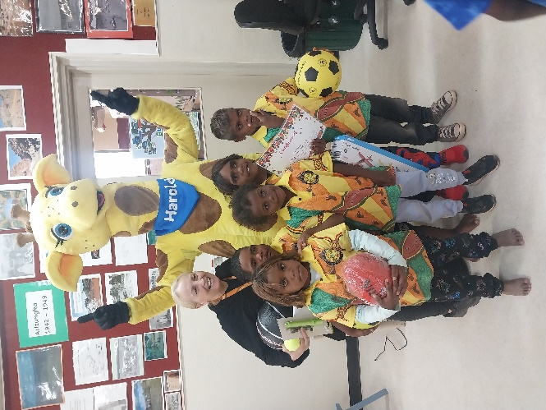A/ - Principal



**Life**

**Education**

**With**

**Harold**

**The**

**Giraffe**

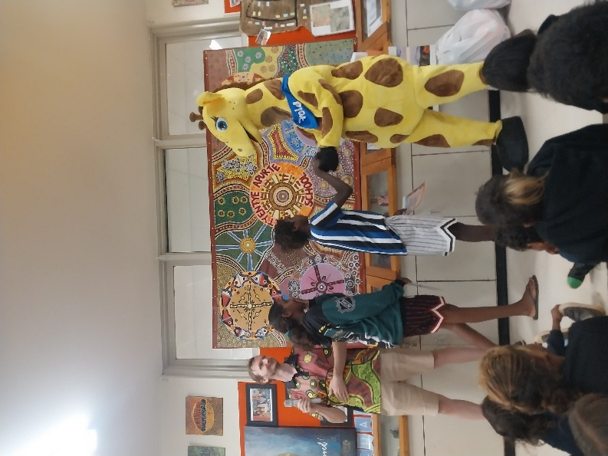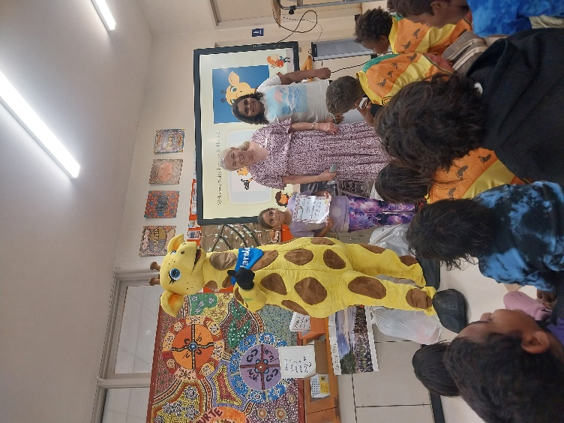

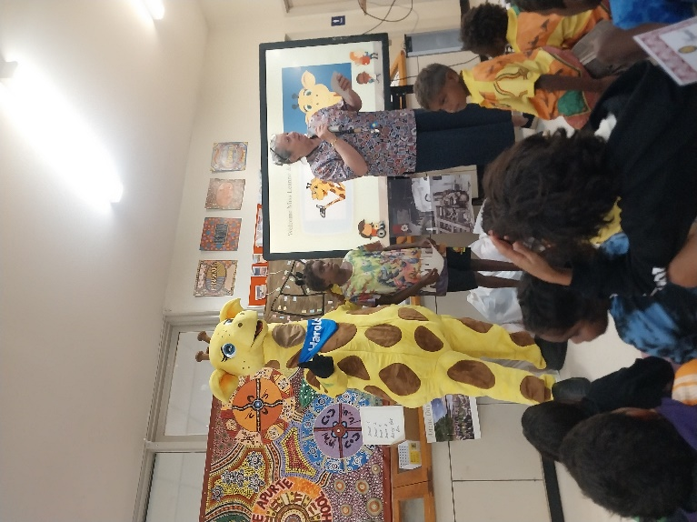

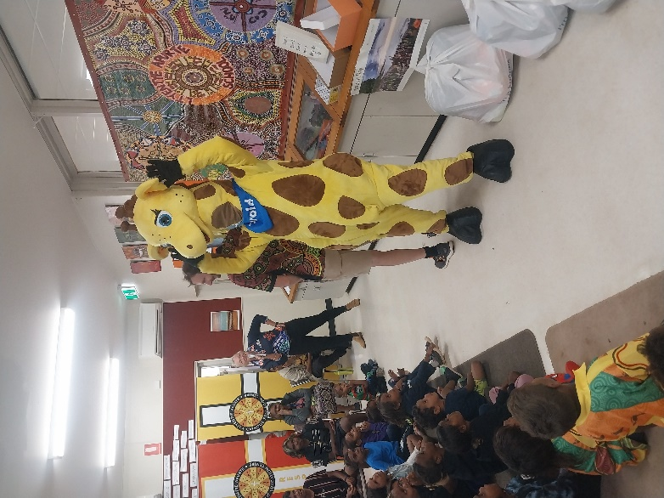

**Harold**

**The**

**Life**

**Education**

**Giraffe**

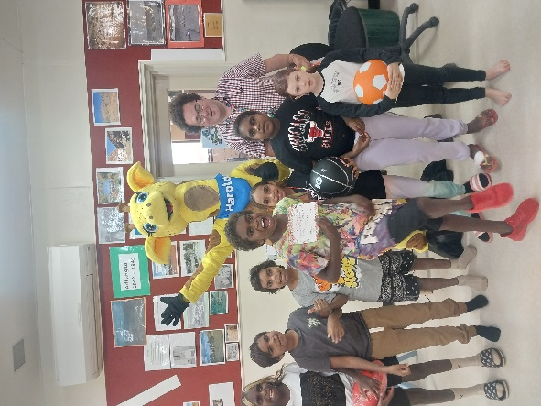

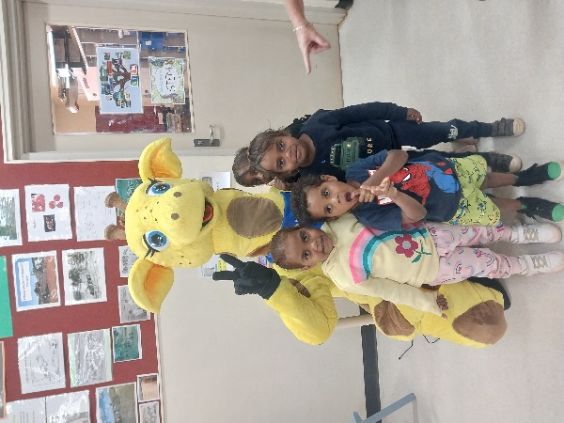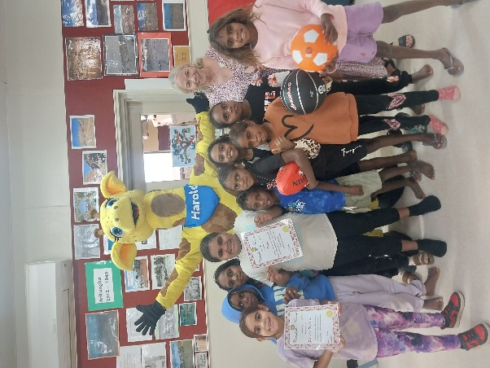

**Road**

**Safety**

**With**

**Hector**

**The**

**Cat**

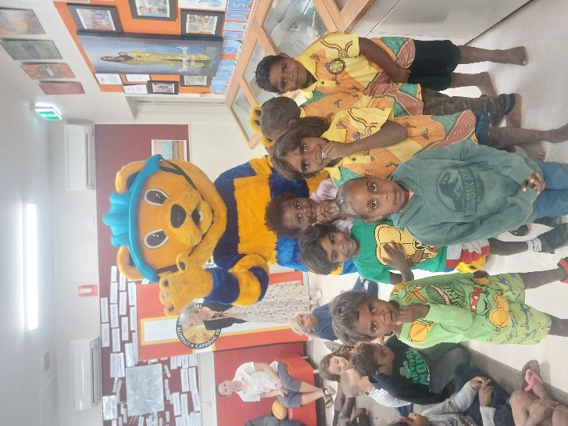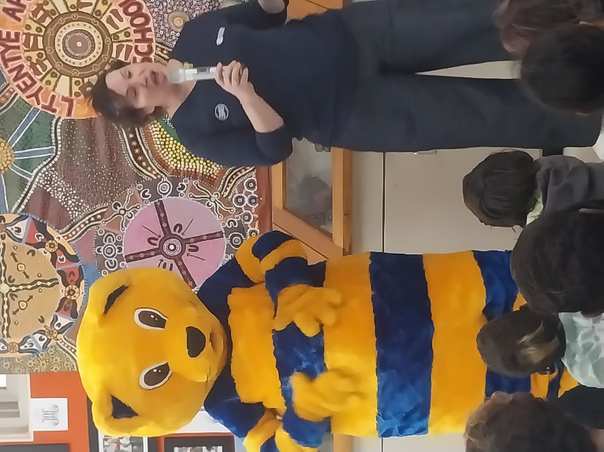

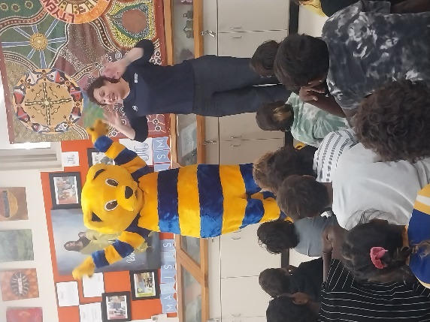

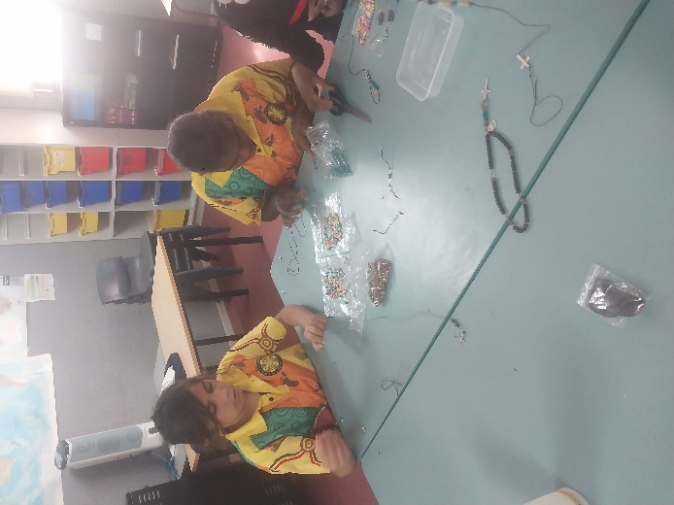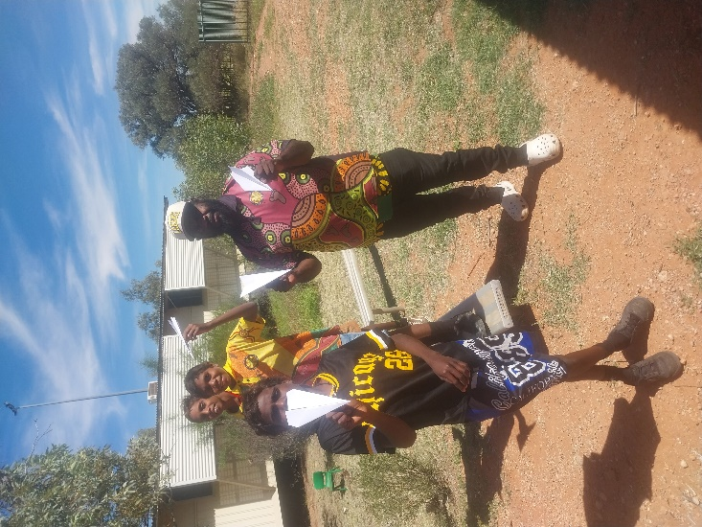

Friday Fun Day Activities

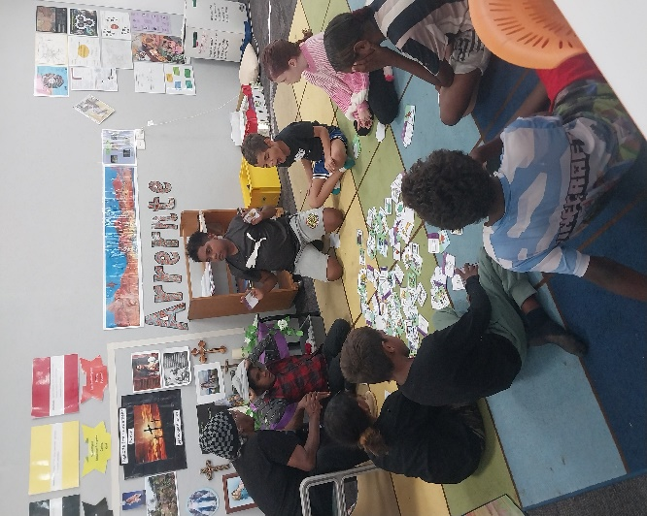

Our New School Bus

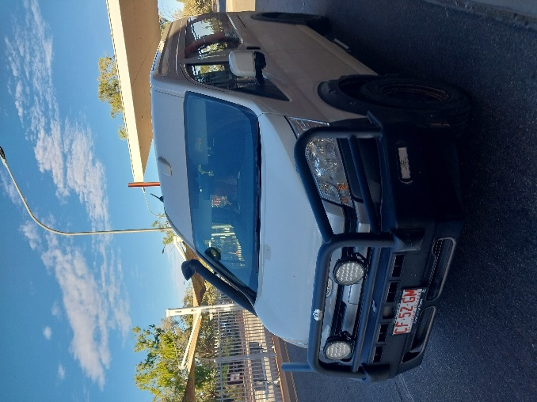

Julia teaching Arrernte Language and Culture.